Data Intelligence Challenge

# 03-05-2022, Tuesday week 2

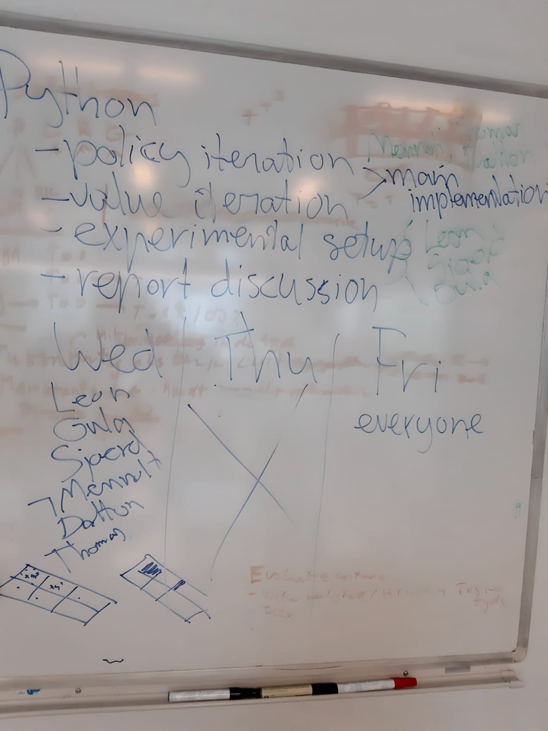

Questions to ask during next Q&A:

Q: Do you do the experiments on the value iteration algorithm, or on the robot driven by the value iteration algorithm?

A: The value and policy iteration actually happen inside the function. So every time you have to propose a move, you calculate values for the whole grid, and then propose you best move. The "iteration" is basically re-calculating these values every move

So we do the experiments on our final implementations. We think of value functions et cetera et cetera that we think work well, and we experiment them on different grids. A robot might work better on some grid than on another given the parameters/policy/value functions

# 04-05-2022, Wednesday week 2

Questions to answer:  
- How far does our robot get?  
- How well does our robot clean?

Assumptions:  
- Battery drain is on  
- There's a load station at starting point

Three different space settings:  
- Big versus small space [2]  
- Room versus house [2]  
- Obstacles versus no obstacles [2]

===> Resulting in 2³ = 8 different spaces to clean

Evaluation metrics:  
- % cleaned  
- % efficiency (#tiles cleaned/#tiles visited)  
- Average reward/return?  
- Number of iterations?

Other parameters to vary:  
- Power drainage  
- Number of robots?